EX7-Create a simple cloud software application for Students Attendance System using any Cloud Service Provider to demonstrate SaaS include the necessary fields such as name of the students, course, present , Absent, course attendance, OD request, grade, attendance percentage, etc.

PROCEDURE:

Step 1: Create a new application and name it as student attendance

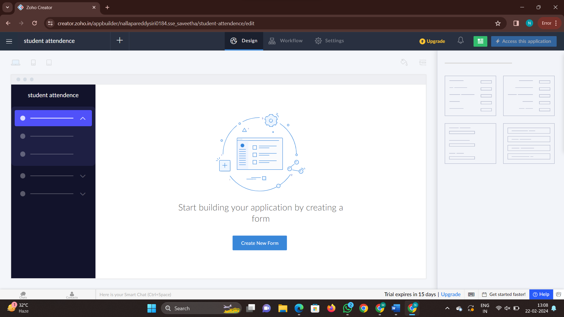

Step2: to create a new form we need to select a form from scratch

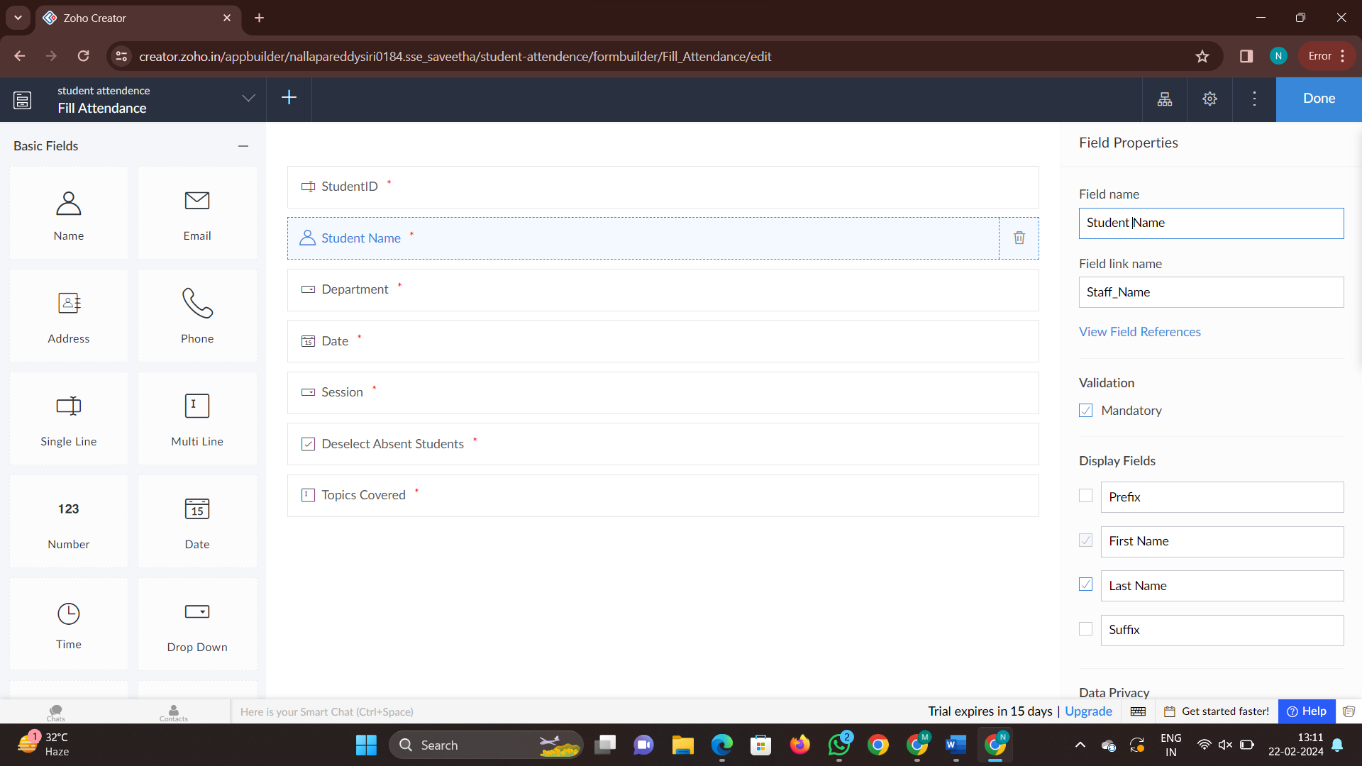

Step 3: now create required number of forms in the application and click on done

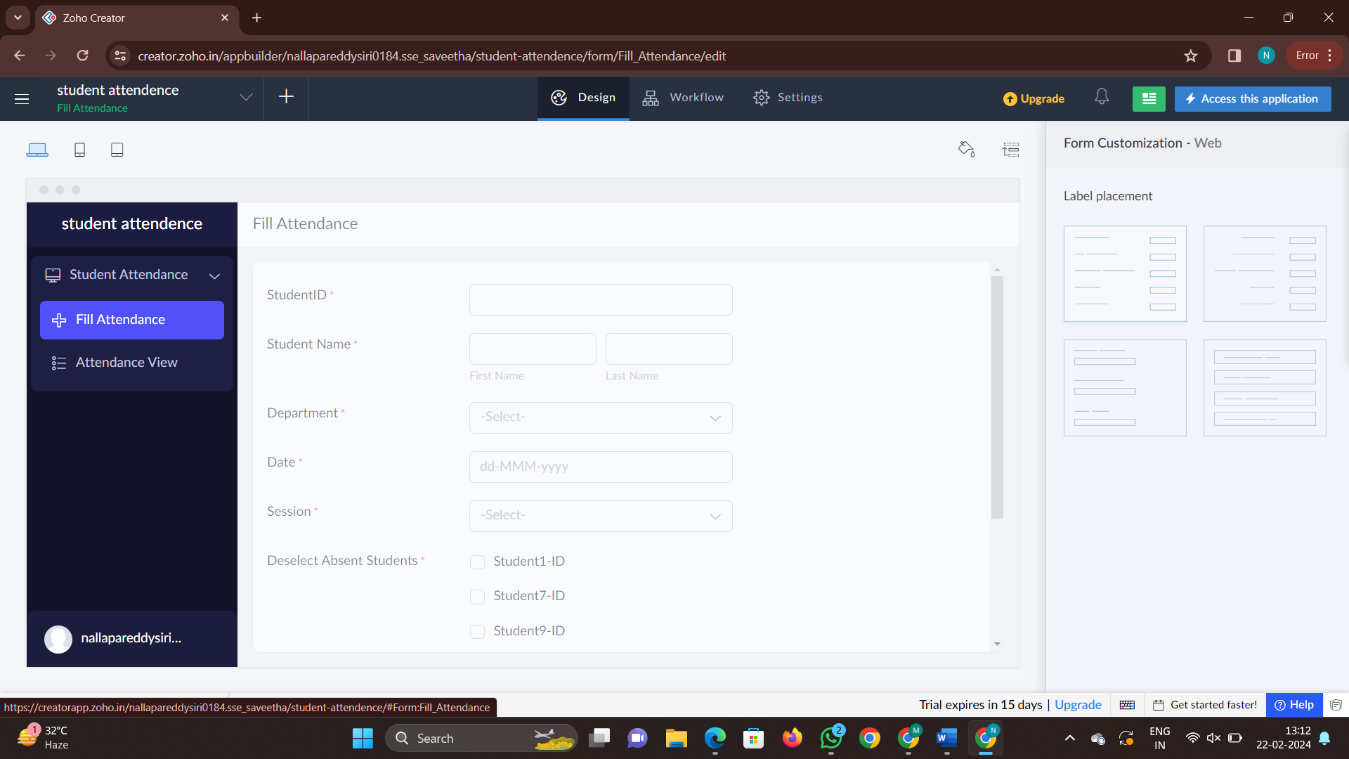

Step 4: Now click on the access this application and try to fill the details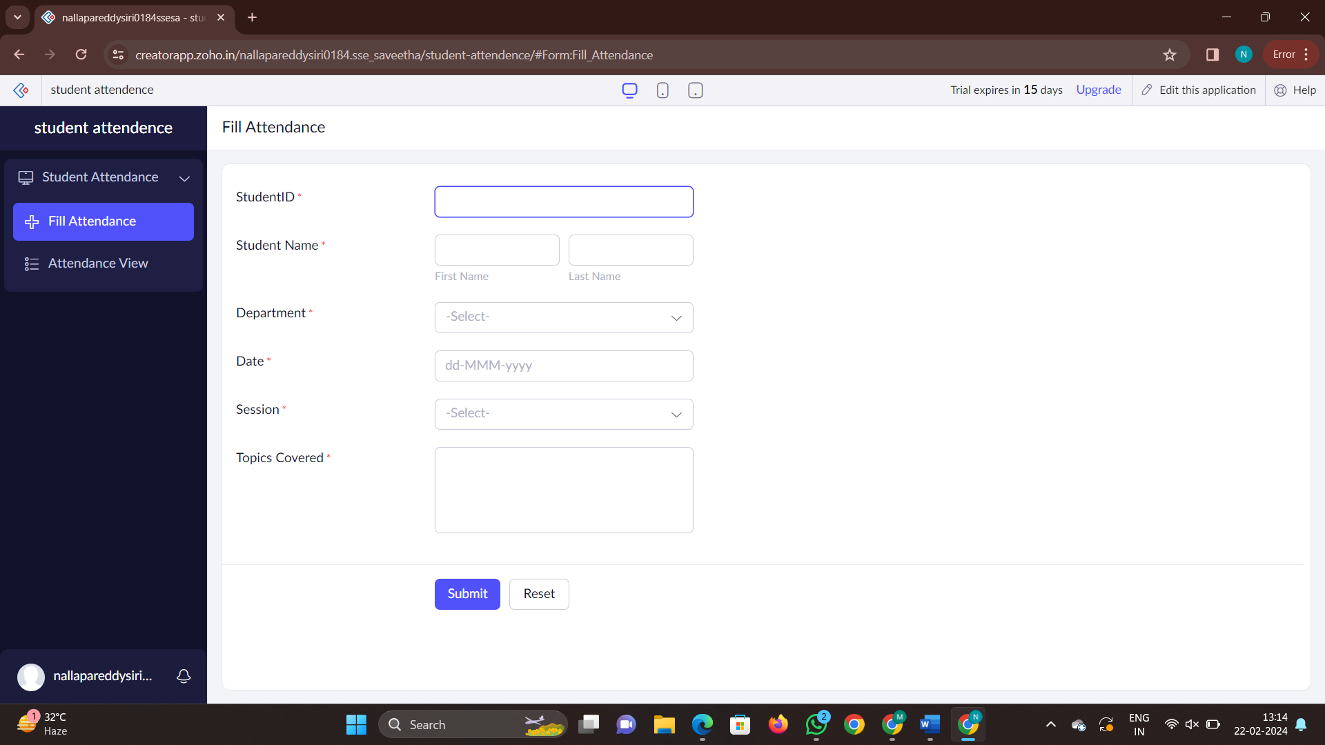

Step 5: Now fill the details and check the report

